UDP Ping-Pong Time Response

UDP Server (udp_server.py)
Receives messages from clients and broadcasts them to all connected clients.

Python Source Code:
import socket

HOST = '127.0.0.1'
PORT = 12345
clients = set()

with socket.socket(socket.AF_INET, socket.SOCK_DGRAM) as server_socket:
server_socket.bind((HOST, PORT))
print(f"Server listening on {HOST}:{PORT}")
while True:
message, client_address = server_socket.recvfrom(1024)
if client_address not in clients:
clients.add(client_address)
print(f"Received message from {client_address}: {message.decode()}")
for client in clients:
if client != client_address:
server_socket.sendto(message, client)

Screenshot of Output:
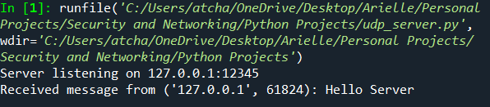

UDP Client (udp_client.py)
Sends messages to the server and displays messages received from other clients.

Python Source Code:
import socket
import threading

HOST = '127.0.0.1'
PORT = 12345

def receive_messages(client_socket):
while True:
try:
message, _ = client_socket.recvfrom(1024)
print(f"\n{message.decode()}\n> ", end="")
except:
break

with socket.socket(socket.AF_INET, socket.SOCK_DGRAM) as client_socket:
client_socket.connect((HOST, PORT))
threading.Thread(target=receive_messages, args=(client_socket,), daemon=True).start()
while True:
message = input("> ")
if message.lower() == 'exit':
break
client_socket.sendto(message.encode(), (HOST, PORT))

Screenshot of Output:
